Fire Resistant Construction Materials

The UK market for passive fire protection products is estimated to be worth around £650m at manufacturers selling prices – excluding installation. The market has grown by around 2% in 2017, with forecasts for 2018 at a similar level. This follows good growth between 2013 and 2015, which represented a period of recovery for the overall construction industry, especially in the education, offices, retail and leisure sectors. The forecasts indicate a more subdued performance, with lower levels of construction activity anticipated as investor confidence has fallen, in the lead up to Brexit.

In terms of structure, the passive fire protection market is comprised of fire-resistant doors, fittings and intumescent seals, cables, partitions and suspended ceilings, glass, structural protection and ductwork and damper systems. Fire-resistant doors, fitting and seals account for the largest shares of the market, with around 60% of the total value.

Recent product innovations in the sector include; intumescent coatings with faster drying times, electronic fire door closers that are linked to fire alarm systems, and more flexible fire-stopping pipe collars that allow a greater range of applications compared to conventional collars.

Key drivers, such as the regulatory aspects of the fire protection sector, are expected to remain unchanged in the short-term, since the Hackitt Review into the Grenfell Tower disaster only covered high-rise buildings and provided no recommendations for immediate change in the technical aspects of Building Regulations. However, modifications are expected in the medium to longer term, and AMA Research also anticipates that there will be other implications for the wider industry, as manufacturers and specifiers alike seek to provide safer environments, possibly leading to positive growth by value.

Forecasts for the passive fire protection market in the medium-term are for modest growth in 2018 and 2019, with slightly higher growth levels by 2020. While the longer-term impact of Brexit remains unclear, investors are likely to remain cautious, and this has resulted in recent forecasts being less optimistic for overall construction sector output growth.

In the short-term, activity in the non-domestic construction sector is likely to slow down, with more subdued growth of around 1-2% 2018-19. The overall market for passive fire protection products such as cable, glass, ceilings, partitions and doors, is dependent on the performance of key construction sectors, such as offices, industrial, entertainment, health and education.

In terms of output, new office construction is forecast to be less positive over 2018-22, following strong output growth of 70% between 2013 and 2017, something which may impact on demand in sectors such as structural fire protection, suspended ceilings and partitions.

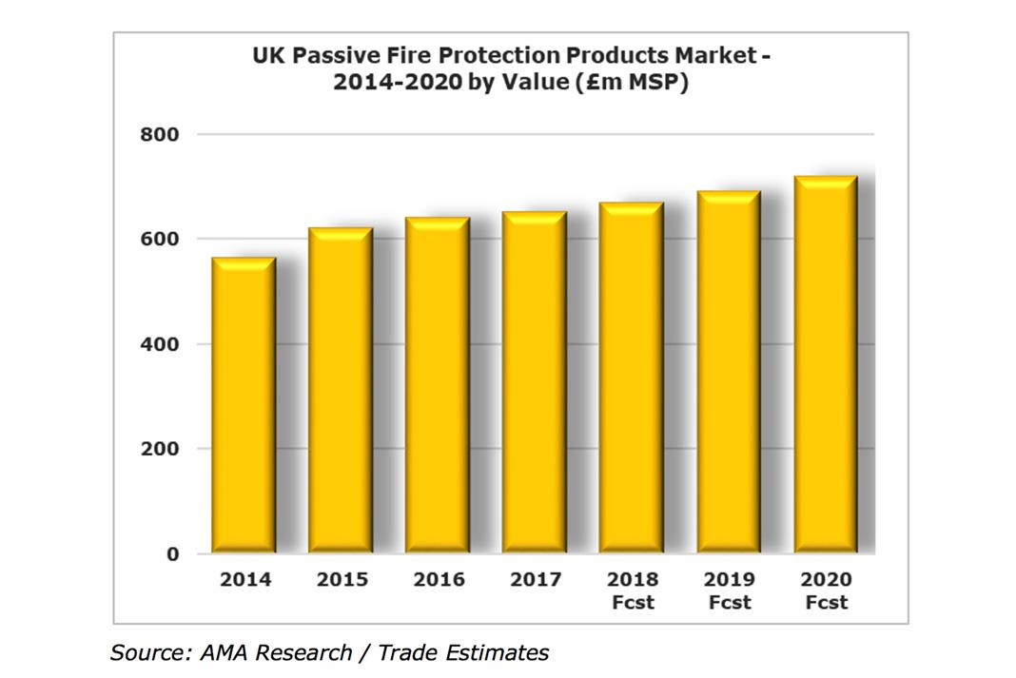

However, the hotel and entertainment sector has shown good growth in recent years and is attracting substantial investment, especially in the budget sector. The university sector has also been positive in terms of new orders in 2018, with future output having the potential to be boosted by demand for new accommodation and facilities for additional students following the removal of the cap on student numbers.

Uncertainty regarding Brexit is expected to have less of an impact on residential construction, where the outlook remains modestly positive, driven in particular by the ongoing imbalance between demand and supply for new housing. Increasing numbers of new flats and apartments built will be the primary source of demand for passive protection in the residential sector.

Other factors influencing the market include the performance of Sterling against both the US dollar and the Euro. Since the 2016 referendum, Sterling’s fall in value and continued relative weakness has meant that materials price inflation has become a key influence in the UK construction market. If this situation continues, it will prompt some value growth in the passive fire protection sector, since a wide range of materials and products is imported.

https://buildingproducts.co.uk/modest-growth-forecasts-passive-fire-protection-products-uk/

***Due to the adverse effects on business confidence and construction activity as a result of COVID-19, AMA Research believes that the*** [***passive fire***](https://www.ifsecglobal.com/fire/beginners-guide-to-passive-fire-protection/) ***market is set to suffer a major downturn in 2020.***

The research firm forecasts that the market is set to dip by 9% over the course of 2020. Prior to this year, the market experienced a period of consistent growth, increasing in value terms by 11% between 2015 and 2019. Much of this can be attributed to a positive performance in various sectors of the non-residential construction industry, such as commercial offices, infrastructure and leisure/entertainment.

The market is expected to remain heavily dependent upon trends in construction output, especially for non-residential applications. The present Government’s intention to invest in infrastructure projects via its [Getting Building Fund](https://www.gov.uk/guidance/getting-building-fund) should provide some market impetus in the short term.

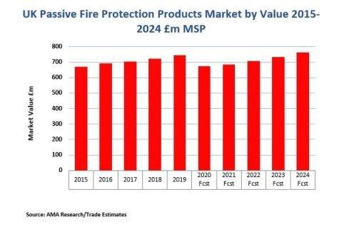

In the residential sector, new regulations are being introduced aimed at rectifying problems identified in ‘The Hackitt Report’ which followed the [Grenfell Tower disaster](https://www.ifsecglobal.com/grenfell-tower/). The [Fire Safety Bill](https://www.ifsecglobal.com/fire/fire-safety-bill/) of March 2020 and the incoming [Building Safety Bill](https://www.ifsecglobal.com/fire/draft-building-safety-bill-announced-by-uk-government/) cover fire safety in residential dwellings and are set to create new areas of responsibility and accountability. More stringent regulations are also expected to affect the wider industry, as the pressure continues to grow upon manufacturers and specifiers alike to provide safer and more fire-resistant environments.

Michelle Turner, Market Research Analyst at AMA Research, comments: “Positive performance in key end use sectors pre-2020 helped bring a spurt of growth to the passive fire market. These same end use sectors are now experiencing detrimental effects as a result of COVID-19 and investment has tightened. Supported by the very need of the products found within this market, and driven by further calls for tighter legislation and stricter accountabilities as a result of the Hackitt Review, the market looks set to remain relatively strong as fire safety remains paramount, helping to keep the boat steady in such adverse conditions.”

Overall, the longer-term scenario for the passive fire protection market remains mixed. Much of this will depend on how well the UK emerges from the various political and economic challenges posed by COVID-19, as well as what form Brexit will eventually take. Growth is projected to return to the market after the downturn experienced in 2020. Between 2021 and 2025, market value is forecast to rise by more than 11%.

<https://www.ifsecglobal.com/fire-news/passive-fire-market-forecast-to-decrease-by-9-during-2020/>

<https://www.radiantinsights.com/research/europe-passive-fire-protection-market>

https://www.businesswire.com/news/home/20190410005503/en/Global-Passive-Fire-Protection-Market-Size-Share-Trends-Analysis-Report-2019---Forecast-to-2025- ResearchAndMarkets.com

Examples of **fire protection boards** and tiles, many of which have been manufactured from industry-leading brands.

* **Gyproc FireLine board**
* **Knauf Fire Panel**
* **GTEC Duripanel**
* **Glasroc Multiboard**
* **Rockwool board**
* **Promat Masterboard**
* **Promat Supalax**

**Fire resistant boards** and **fire resistant tiles** utilise high-density core and various other additives within the materials which enhance their fireproof qualities.

**Fireproof plasterboard** is primarily used in interior partition walls as well as roofs and ceilings. This type of product also adds additional fire protection measures where additional levels of resistance to heat might be needed. Examples of this include garages, cellars and attics.

Promat

Promat have provided and manufactured **fire resistant board** for over 30 years now, all of which are high-quality containing **fireproof materials** that offer premium protection. Promat’s fire-resistant products include:

* **Promat Supalax**
* **Promat Masterboard**
* **Thermal insulation**
* **Fireproof plasterboard** (that is also moisture resistant)
* **Non-combustible wall lining**

Promat Supalax is fire-resistant wall lining board carries an A1 fire rating, which can offer up to 240 minutes of fire protection, dependant on the application. This can be used in domestic, commercial and industrial builds, commonly in applications such as ceilings, flooring and roofs as well as internal partitioning.

Promat Masterboard offers 30 minutes of fire protection, which might not sound like much but the added caveat is this **fire resistant plasterboard** is also heavily moisture-resistant. This type of board is suitable for applications such as swimming pool ceilings and walls, tile backing, canopy linings and any other internal building project with high water levels.

British Gypsum

What is the fire resistance performance of **British Gypsum FireLine board**? Fire resistance is based on a number of factors. Fire resistant plasterboard from a brand such as British Gypsum contains metal studs and screw fixings within the plasterboard linings to enhance a board’s overall fire performance. All components within the board will determine the fire resistance of fireboard.

Single layer **15mm Gyproc FireLine** provides 60 minutes.

Double layer **15mm Gyproc WallBoard** provides 90 minutes, while 12.5mm provides 120 minutes.

**Gypsum FireLine** contains additives such as glass fibre which increase the fire protection attributes. This additional level of performance compared to standard plasterboard enables this fireboard to be used in multiple applications, including:

* **Partitioning**
* **Ceiling systems**
* **Domestic separating walls**
* **Hallways and corridors**
* **Extension work**
* **Steel encasement projects**

ttps://www.buildingmaterials.co.uk/commercial/fire-protection-products/boards-tiles

# -- Fire Protection Boards

Fire Protection Boards

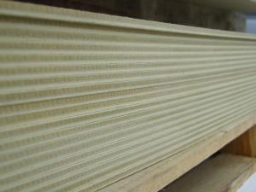

RCM Ywall

Fire Protection Boards can be used for internal and external applications. Fire Protection Boards are built to withstand high temperatures and temperature changes. The boards are resistant to changes in heat and moisture and are non combustible. Fire Protection Boards can be cut, drilled, nailed and worked with standard working tools. Applications include fire protection for ceilings, soffits, partitions, laminate, door facing, roofing and ducting. Applications and fire rating scores vary based on the manufacturer.

Supalux

Supalux is Class O fire rated for surface spread of flame as well as being a non-combustible, high performance board. Providing up to 240 minutes fire protection to any project, Supalux also provides moisture resistance in damp and humid environments. Supalux is commonly used for internal partitions, external walls, internal walls, ceilings and non-combustible linings. EN13501-1/BS476-4

Masterboard

Masterboard is a Class O building board with limited combustibility providing up to 30 minutes fire protection. This board is also suitable for external use in semi-exposed applications, whilst adding its fire rating qualities. BBS Facades: 90-2500/ Euro Class A2

Siltech

Siltech is a non-combustible flexible calcium silicate building board which can be used in a variety of applications including partitioning, under floor core, suspended ceilings, door linings, internal walls and roof linings or as part of a range of OEM products which require a non-combustible board. BS476-4

Cembrit FR

Cembrit FR is a versatile, Class A1 fire rated internal lining board suitable for partition walls, ceilings and floors. Cembrit FR will provide up to 120 minutes of fire resistance when used on the structure with insulation or 60 minutes when used without insulation. Cembrit FR building boards are lightweight and robust, making them ideal for offsite construction. BS476-21/BGSI 50554/89 Warres No: 535764/91

YWall

Ywall is a non-combustible cement/calcium building board that can be used for applications that require a slightly lighter board with improved fire properties. Ywall offers very similar properties to that of cement particle board, however due to the calcium additives, it offers a much greater fire resistance. This fire protection board has a smooth surface on the front and rough face on the back. BS476-4

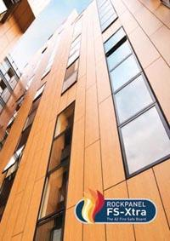

FS-Xtra

Decorative Fire Protection Boards

ROCKPANEL FS-Xtra

Since March 2013, ROCKPANEL façade boards, in European Fire Classification level A2-s1, d0; have been available in all ROCKPANEL designs. Now, complemented by the new FS-Xtra grade; which further enhances its fire safety charactersitiscs; the ROCKPANEL range offers building engineers and constructors unrestricted design freedom for any application and façade area.

For advice on any of these Fire Protection Boards, please [contact our team](https://www.bbsfacades.co.uk/contact/) of specialists.

**Example to beat**

Looking over the marketplace this company looks like an interesting competitor.

New technology aimed at replacing plywoods and OSB.

https://www.resistant.co.uk/products/base-board/

Look at website I have attached technology detail. Are there other companies like this?

How does their product portfolio range over price and applications?

Are there other companies with innovative products like this?

**MULTI-PRO 2400MM X 1200MM 12MM SE GEN/PURPOSE BOARD**

Fire rated A1 non combustable

Boiler backer board

Tile backer

Stove surround

£72.50